Participation of GDC Chinthapalli Students in Govt.Degree College for women (A)
Golden Jubilee Celebrations Competitions
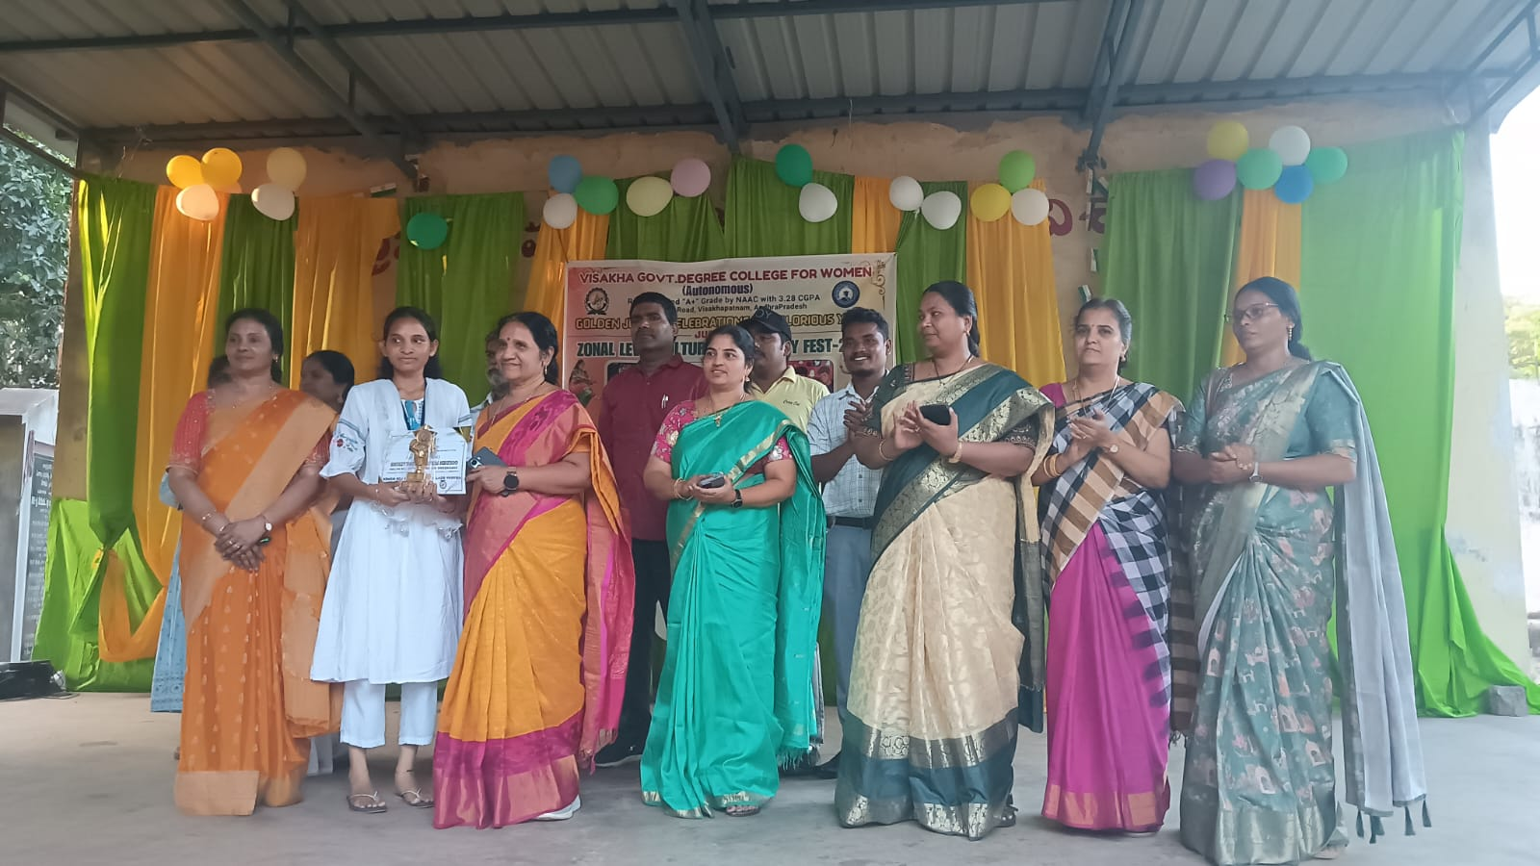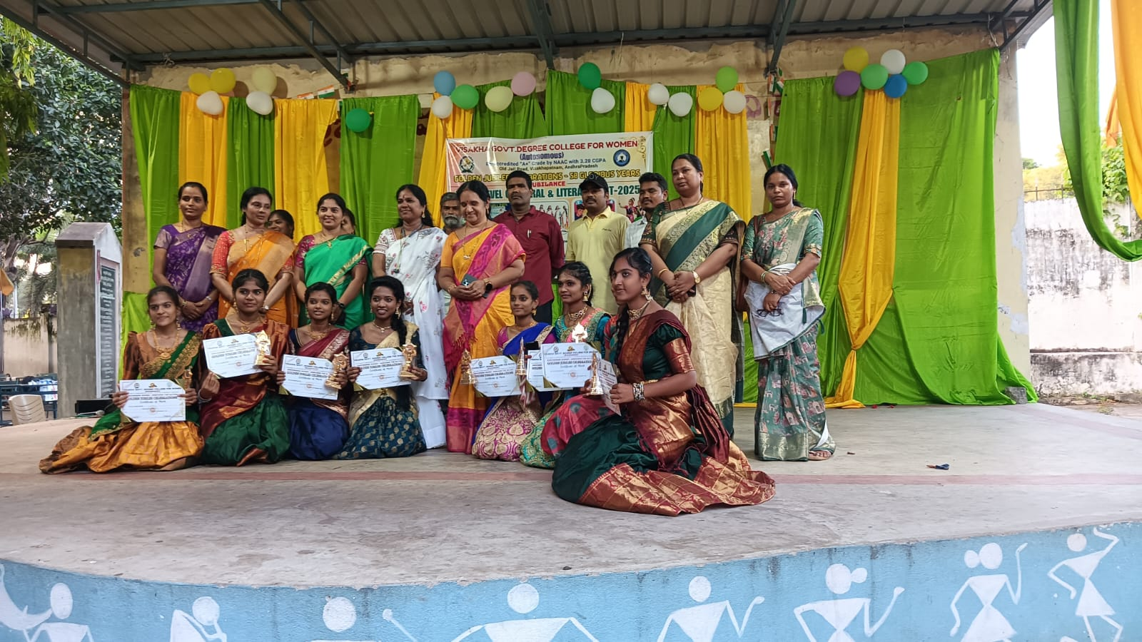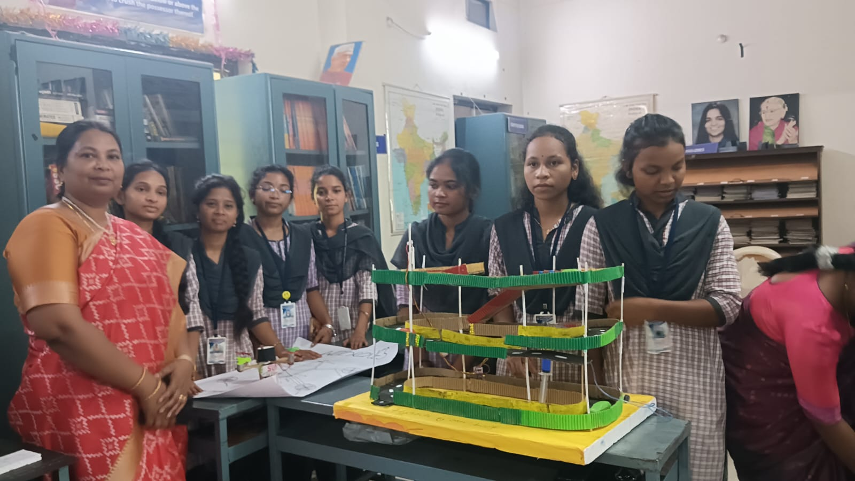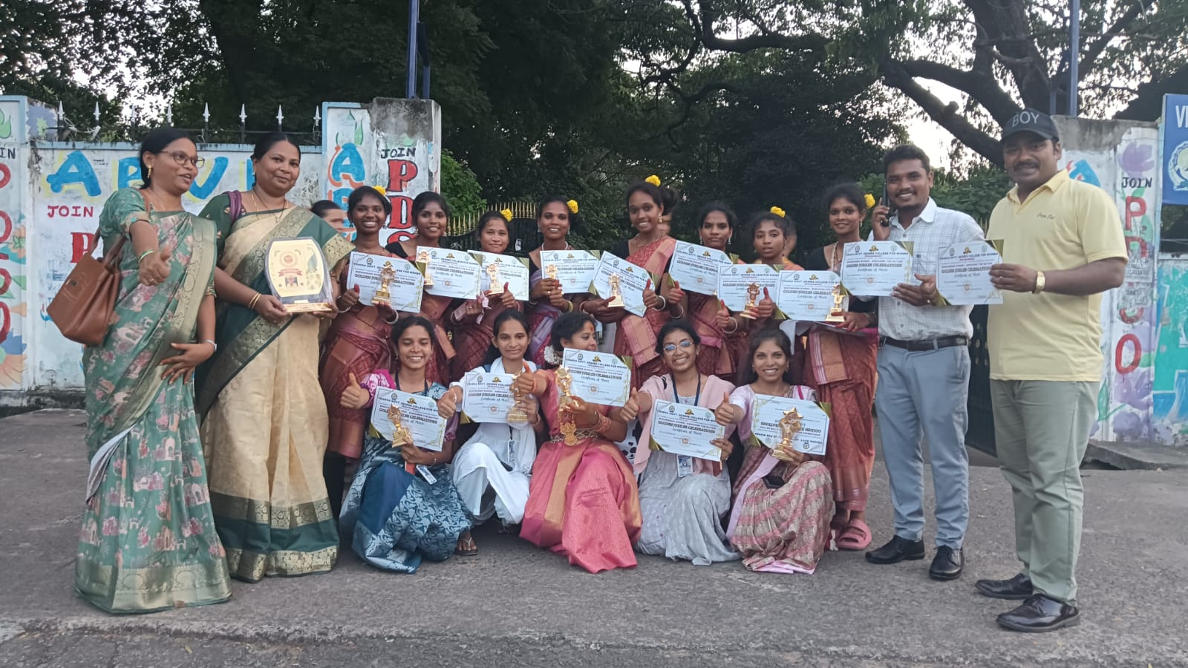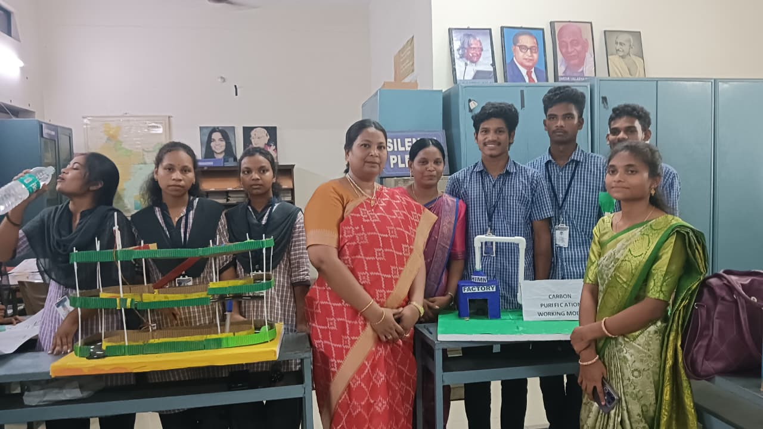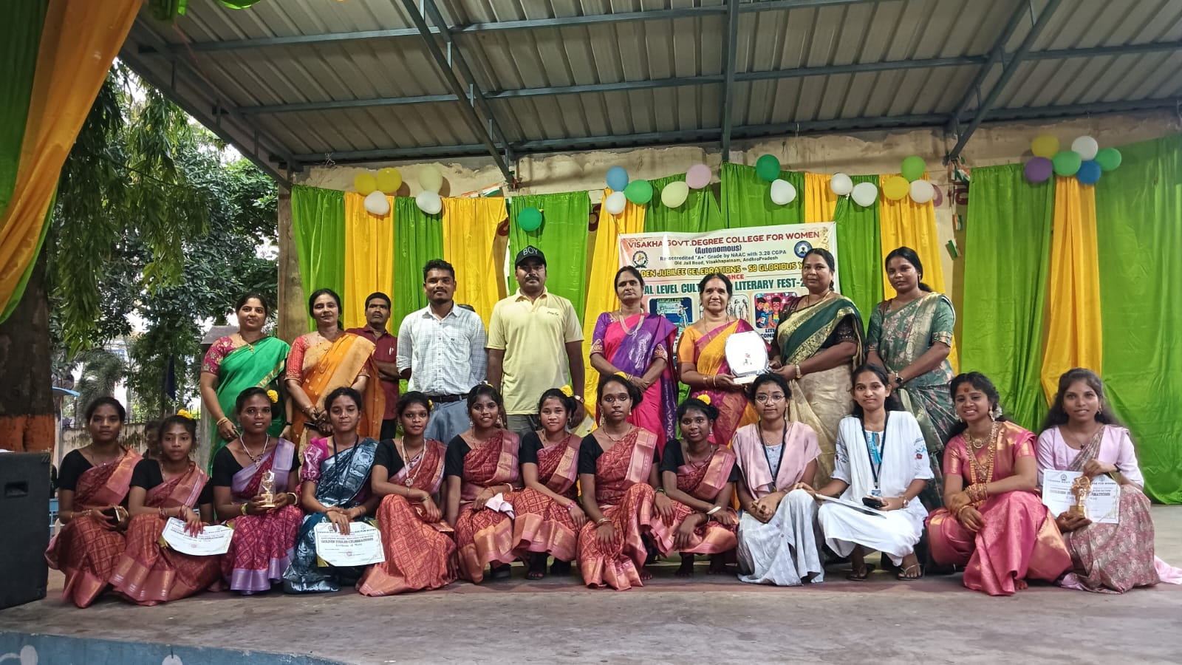

The students of Government Degree College Chinthapalli participated in various competitions conducted as part of the Golden Jubilee Celebrations of Government Degree College for Women Visakhapatnam on 18th and 19th September. The competitions were conducted at the zonal level, and students from several colleges participated in the events.

A team of students from GDC Chinthapalli actively took part in different cultural and academic competitions and brought laurels to the college.

In the Solo Song Competition, S. Jyothi, a student of I B.Sc. Zoology, delivered an excellent performance and secured the First Prize.

In the Group Song Competition, the student S Jyothi,P Ramya, Vanitha, Dhanalakshmi of GDC Chinthapalli once again showcased their musical talent and teamwork and secured the First Prize.

The students also enthusiastically participated in the Group Dance Competition, presenting an energetic and colourful performance and the Secured Second Prize.

In the Project Presentation on the topic “New Innovative Ideas,” a team consisting of K. Swarupini (Botany), K. Gowthami (Computer Science), and P. Sujatha represented the college and secured the Third Prize.

In addition, students V. Rajitha (Computer Science), Rajeswari (B.A.), Vikas (B.A.), Praveen (B.A.), and Prasad (B.A.) participated in the Poster Presentation on the topic “New Innovative Ideas.” They explained their innovative idea effectively before the judges and audience.

The students were accompanied and guided by Dr. Dasari Kejiya, Lecturer in English, S. R.Srinivasa Raju, Lecturer in English, Mayuri, Lecturer in Economics, and K. Nageswara Rao, who supported and encouraged the participants throughout the event.

The achievements of the students in these competitions brought great pride and recognition to Government Degree College, Chinthapalli, and such participation helps in developing students’ confidence, creativity, and academic excellence.

